CSA0672-DESIGN AND ANALYSIS OF ALGORTHM

NAME : K.Santhoshini

REGNO: 192111121

1. MERGE SORT

PROGRAM:

#include <stdio.h>

#include <stdlib.h>

void merge(int arr[], int l, int m, int r) {

int i, j, k;

int n1 = m - l + 1;

int n2 = r - m;

int L[n1], R[n2];

for (i = 0; i < n1; i++)

L[i] = arr[l + i];

for (j = 0; j < n2; j++)

R[j] = arr[m + 1 + j];

i = 0;

j = 0;

k = l;

while (i < n1 && j < n2) {

if (L[i] <= R[j]) {

arr[k] = L[i];

i++;

} else {

arr[k] = R[j];

j++;

}

k++;

}

while (i < n1) {

arr[k] = L[i];

i++;

k++;

}

while (j < n2) {

arr[k] = R[j];

j++;

k++;

}

}

void mergeSort(int arr[], int l, int r) {

if (l < r) {

int m = l + (r - l) / 2;

mergeSort(arr, l, m);

mergeSort(arr, m + 1, r);

merge(arr, l, m, r);

}

}

int main() {

int n, i;

printf("Enter the number of elements: ");

scanf("%d", &n);

int arr[n];

printf("Enter %d integers:\n", n);

for (i = 0; i < n; i++) {

scanf("%d", &arr[i]);

}

mergeSort(arr, 0, n - 1);

printf("\nSorted array is: \n");

for (i = 0; i < n; i++) {

printf("%d ", arr[i]);

}

printf("\n");

return 0;

}

OUTPUT:

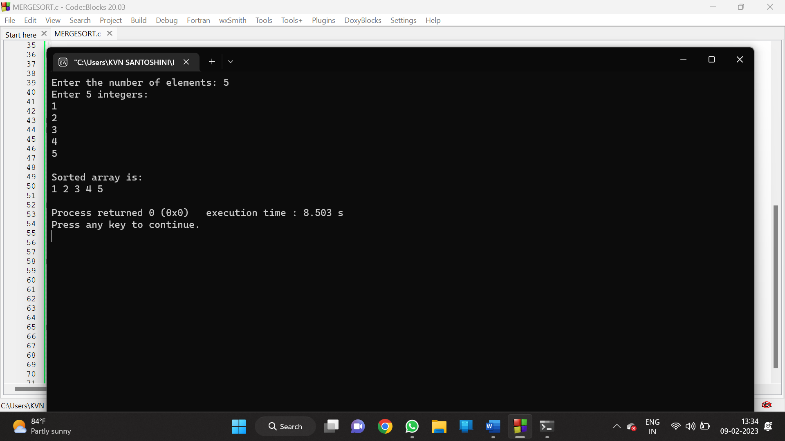

1. MINIMUM AND MAXIMUM IN ARRAY

PROGRAM:

#include<stdio.h>

#include<stdio.h>

int max, min;

int a[100];

void maxmin(int i, int j)

{

int max1, min1, mid;

if(i==j)

{

max = min = a[i];

}

else

{

if(i == j-1)

{

if(a[i] <a[j])

{

max = a[j];

min = a[i];

}

else

{

max = a[i];

min = a[j];

}

}

else

{

mid = (i+j)/2;

maxmin(i, mid);

max1 = max; min1 = min;

maxmin(mid+1, j);

if(max <max1)

max = max1;

if(min > min1)

min = min1;

}

}

}

int main ()

{

int i, num;

printf ("\nEnter the total number of numbers : ");

scanf ("%d",&num);

printf ("Enter the numbers : \n");

for (i=1;i<=num;i++)

max = a[0];

min = a[0];

maxmin(1, num);

printf ("Maximum element in an array : %d\n", max);

return 0;

}

OUTPUT:

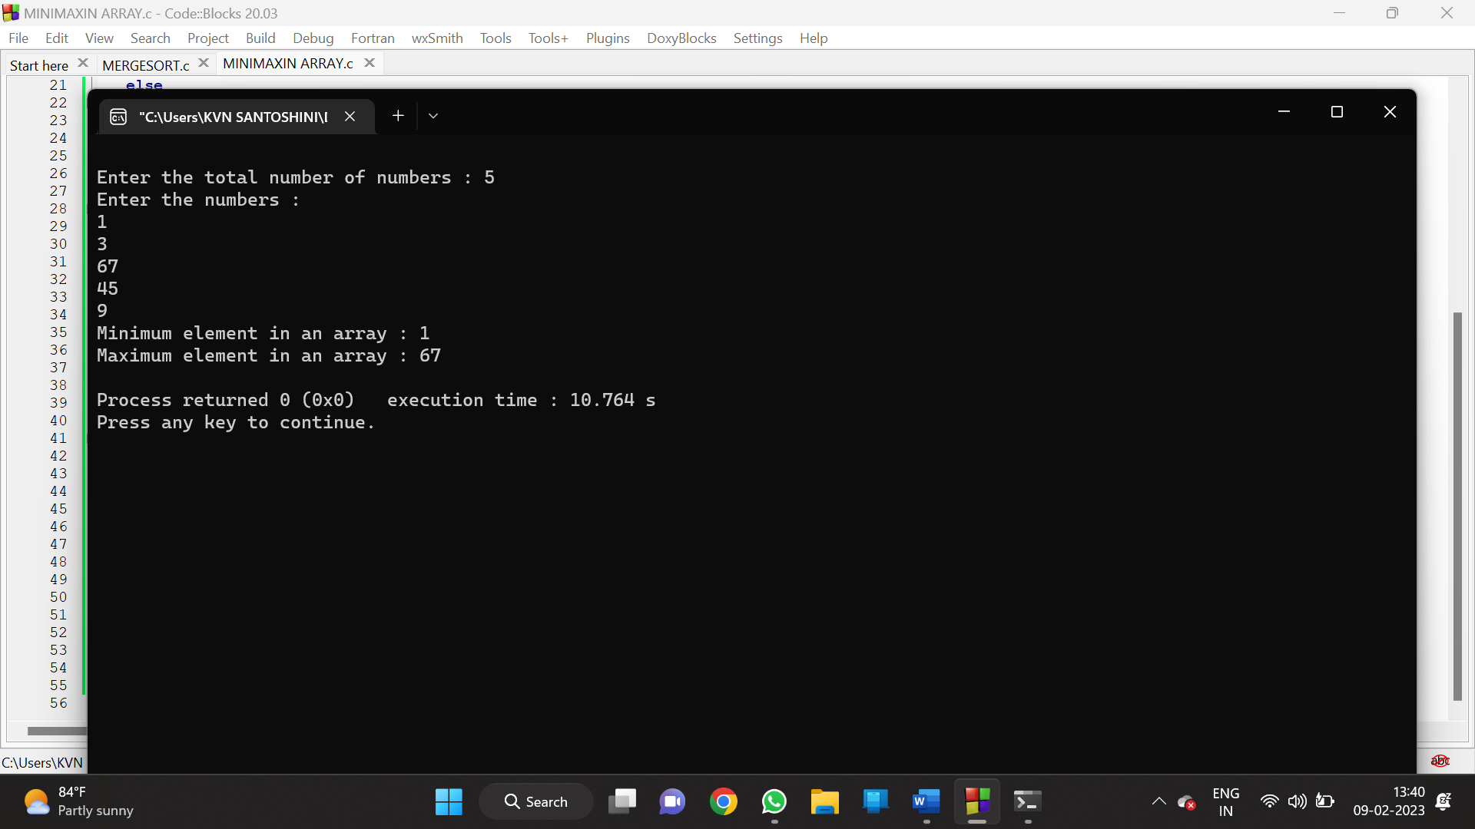

1. SUBSETS OF THE GIVEN SET

PROGRAM:

#include <stdio.h>

char string[50], n;

void subset(int, int, int);

int main()

{

int i, len;

printf("Enter the len of main set : ");

scanf("%d", &len);

printf("Enter the elements of main set : ");

scanf("%s", string);

n = len;

printf("The subsets are :\n");

for (i = 1;i <= n;i++)

subset(0, 0, i);

}

void subset(int start, int index, int num_sub)

{

int i, j;

if (index - start + 1 == num_sub)

{

if (num_sub == 1)

{

for (i = 0;i < n;i++)

printf("%c\n", string[i]);

}

else

{

for (j = index;j < n;j++)

{

for (i = start;i < index;i++)

printf("%c", string[i]);

printf("%c\n", string[j]);

}

if (start != n - num_sub)

subset(start + 1, start + 1, num_sub);

}

}

else

{

subset(start, index + 1, num_sub);

}

}

OUTPUT:

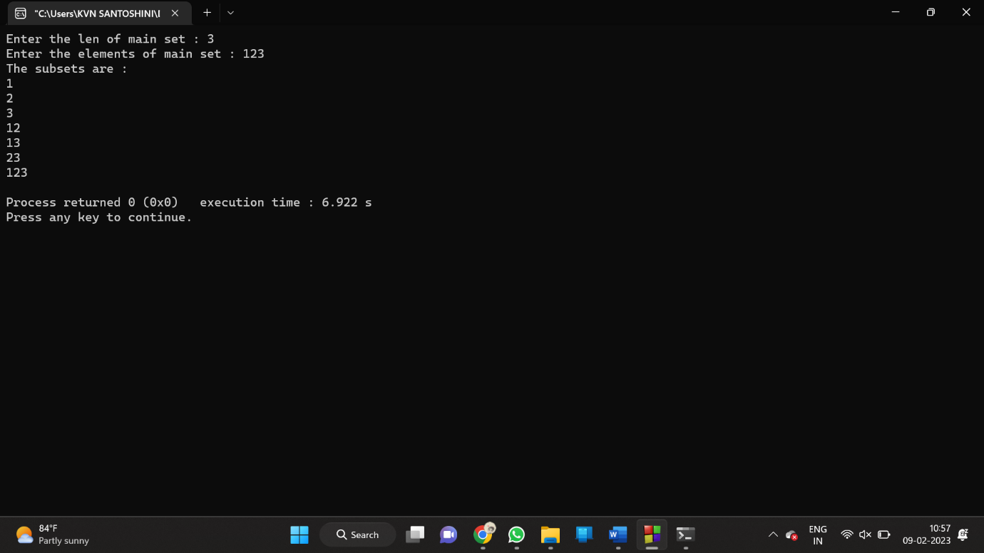

1. CONTAINER LOADING PROBLEM

PROGRAM:

#include <stdio.h>

#include <stdlib.h>

#define MAX_ITEMS 100

#define MAX_WEIGHT 100

int weight[MAX_ITEMS];

int value[MAX_ITEMS];

int dp[MAX_ITEMS][MAX_WEIGHT];

int max(int a, int b) {

return (a > b) ? a : b;

}

int knapsack(int n, int w) {

int i, j;

for (i = 0; i <= n; i++) {

for (j = 0; j <= w; j++) {

if (i == 0 || j == 0) {

dp[i][j] = 0;

} else if (weight[i-1] <= j) {

dp[i][j] = max(value[i-1] + dp[i-1][j-weight[i-1]], dp[i-1][j]);

} else {

dp[i][j] = dp[i-1][j];

}

}

}

return dp[n][w];

}

int main() {

int n = 4;

int w = 10;

weight[0] = 1;

weight[1] = 2;

weight[2] = 4;

weight[3] = 5;

value[0] = 5;

value[1] = 4;

value[2] = 6;

value[3] = 8;

int result = knapsack(n, w);

printf("Result: %d\n", result);

return 0;

}

OUTPUT:

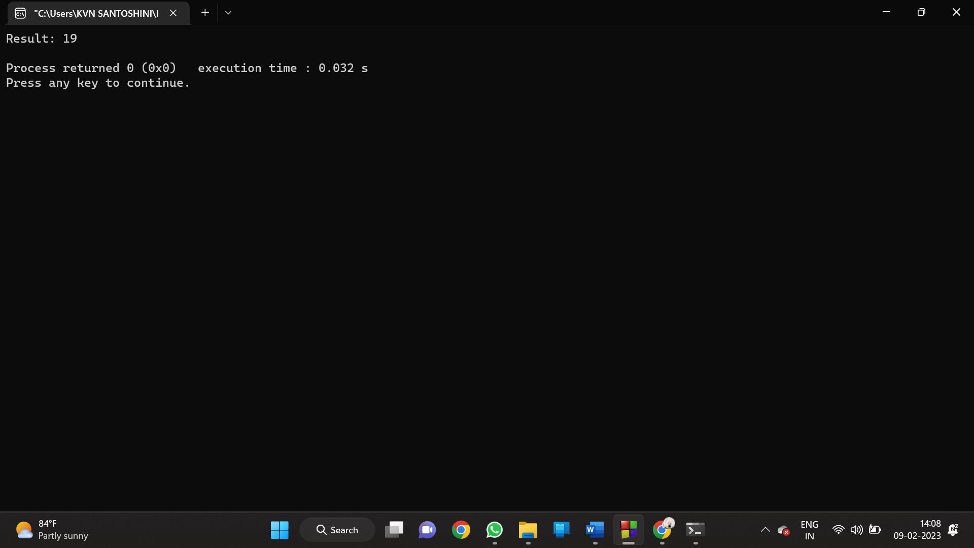

1. MINIMUM SPANNING TREE WITH PRIMS ALGORITHM

PROGRAM:

#include <stdio.h>

#include <limits.h>

#define V 5

int minKey(int key[], bool mstSet[]) {

int min = INT_MAX, minIndex;

for (int v = 0; v < V; v++)

if (mstSet[v] == false && key[v] < min)

min = key[v], minIndex = v;

return minIndex;

}

void printMST(int parent[], int graph[V][V]) {

printf("Edge \tWeight\n");

for (int i = 1; i < V; i++)

printf("%d - %d \t%d \n", parent[i], i, graph[i][parent[i]]);

}

void primMST(int graph[V][V]) {

int parent[V];

int key[V];

bool mstSet[V];

for (int i = 0; i < V; i++)

key[i] = INT_MAX, mstSet[i] = false;

key[0] = 0;

parent[0] = -1;

for (int count = 0; count < V - 1; count++) {

int u = minKey(key, mstSet);

mstSet[u] = true;

for (int v = 0; v < V; v++)

if (graph[u][v] && mstSet[v] == false && graph[u][v] < key[v])

parent[v] = u, key[v] = graph[u][v];

}

printMST(parent, graph);

}

int main() {

int graph[V][V] = {{0, 2, 0, 6, 0},

{2, 0, 3, 8, 5},

{0, 3, 0, 0, 7},

{6, 8, 0, 0, 9},

{0, 5, 7, 9, 0}};

primMST(graph);

}

OUTPUT:

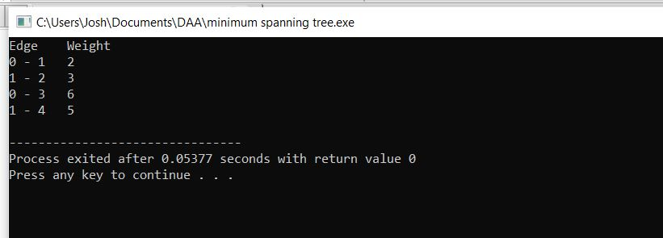

6)N-QUEENS PROBLEM

PROGRAM:

#include <stdio.h>

#include <stdbool.h>

#define N 8

int col[N];

bool check(int row) {

int i;

for (i = 0; i < row; i++)

if (col[i] == col[row] ||

row - i == col[row] - col[i] ||

row - i == col[i] - col[row])

return false;

return true;

}

void backtrack(int row) {

int i;

if (row == N) {

for (i = 0; i < N; i++) printf("(%d, %d)\n", i, col[i]);

printf("\n");

return;

}

for (i = 0; i < N; i++) {

col[row] = i;

if (check(row)) backtrack(row + 1);

}

}

int main() {

backtrack(0);

return 0;

}

OUTPUT:

O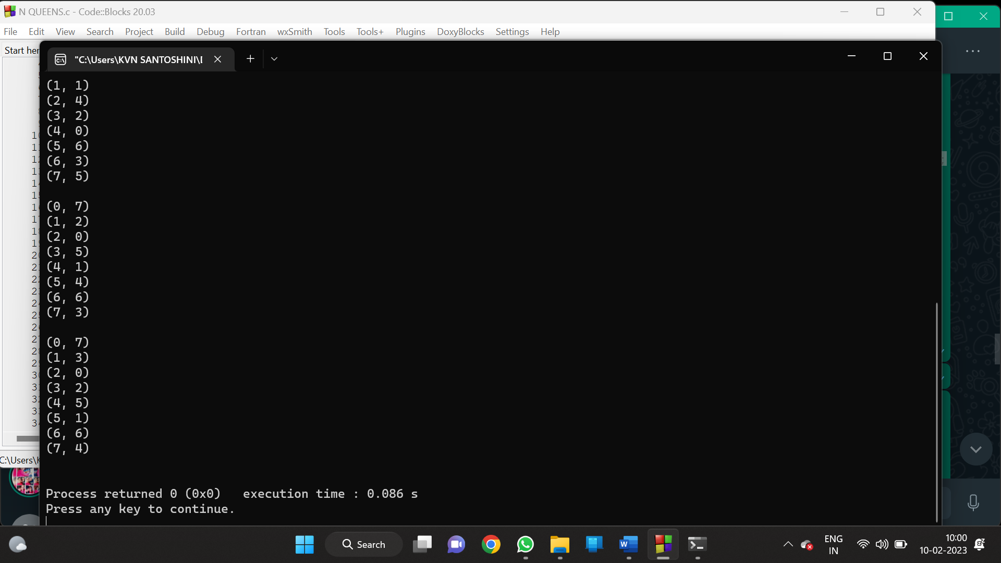

7)TRAVELSALES MAN PROBLEM

PROGRAM:

#include <stdio.h>

#include <stdbool.h>

#define MAX 20

#define INF 99999

int n, d[MAX][MAX], x[MAX];

int best_tour_length = INF, tour_length[MAX];

void backtrack(int curr_pos) {

int i;

if (curr_pos == n) {

tour_length[curr_pos] = d[x[n - 1]][x[0]];

int tour = 0;

for (i = 0; i < n; i++) tour += tour_length[i];

if (tour < best_tour_length) best_tour_length = tour;

return;

}

for (i = 0; i < n; i++) {

if (x[i] == -1) {

x[i] = curr_pos;

tour_length[curr_pos] = d[x[curr_pos - 1]][i];

backtrack(curr_pos + 1);

x[i] = -1;

}

}

}

int main() {

int i, j;

printf("Enter the number of cities: ");

scanf("%d", &n);

printf("Enter the distance matrix:\n");

for (i = 0; i < n; i++)

for (j = 0; j < n; j++) {

scanf("%d", &d[i][j]);

x[i] = -1;

}

x[0] = 0;

backtrack(1);

printf("The minimum tour length is: %d\n", best_tour_length);

return 0;

}

OUTPUT:

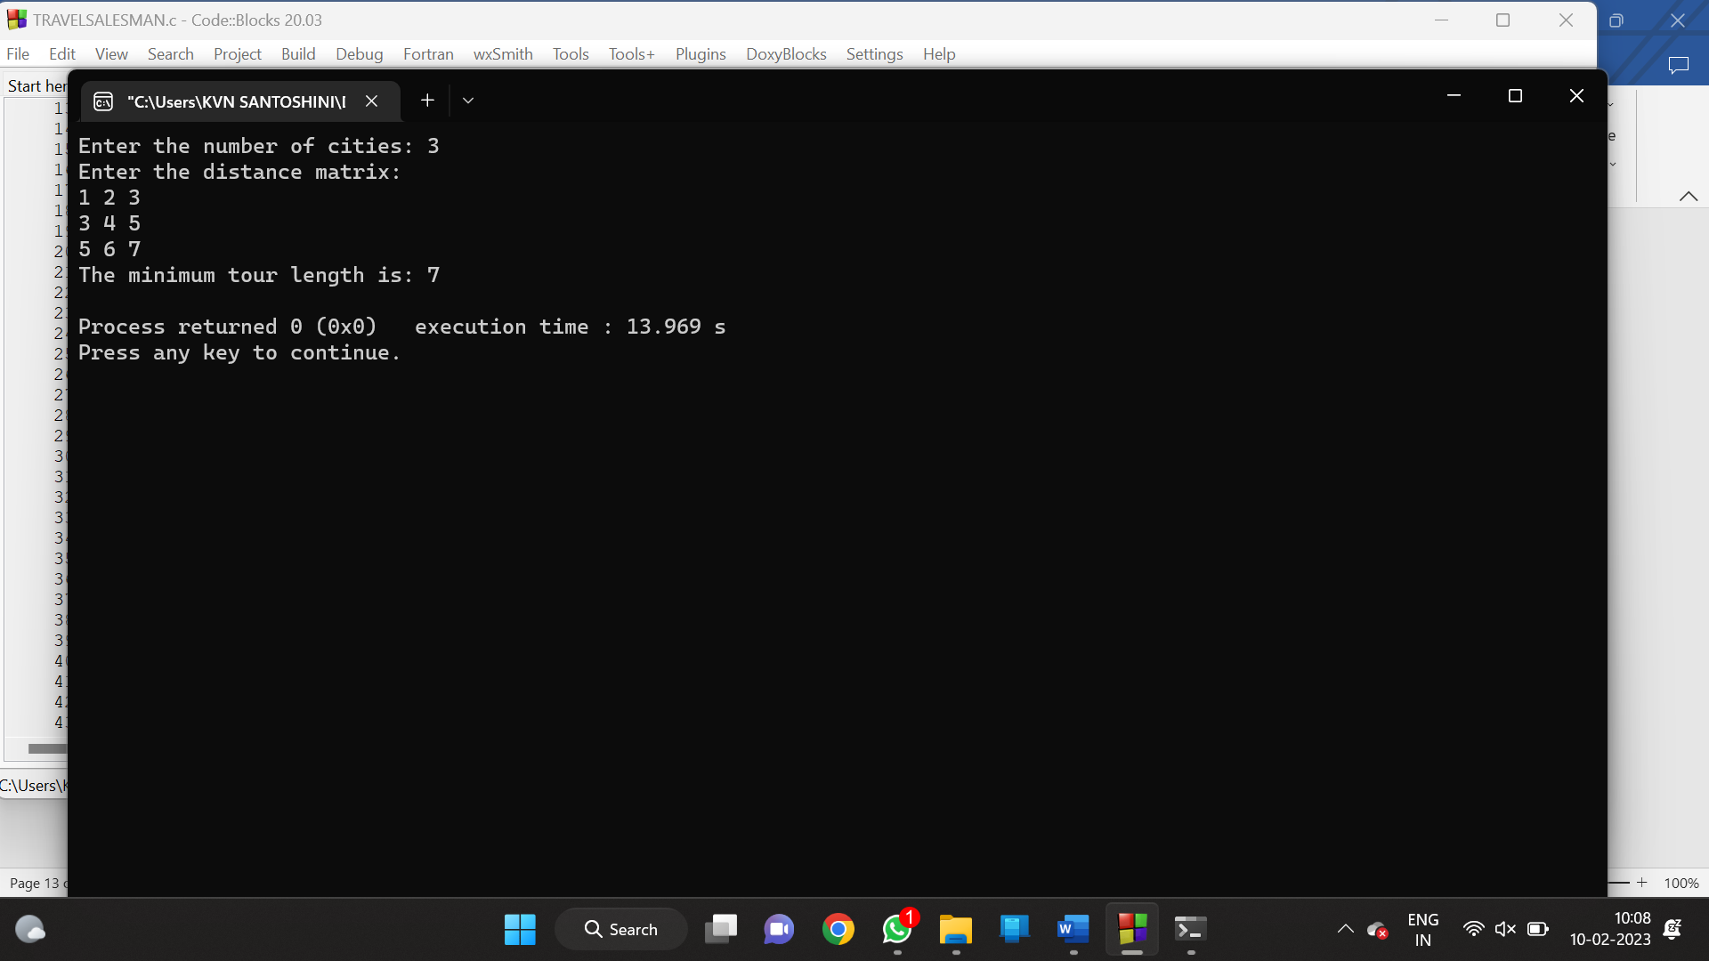

8) KNAPSACK USING DYNAMIC PROGRAMMING

PROGRAM:

#include <stdio.h>

#include <stdlib.h>

#define MAX_WEIGHT 100

// Struct to represent an item

struct Item {

int weight;

int profit;

};

// Function to find the maximum profit for the knapsack

int knapsack(struct Item items[], int n, int weight) {

int dp[n + 1][weight + 1];

for (int i = 0; i <= n; i++) {

for (int w = 0; w <= weight; w++) {

if (i == 0 || w == 0) {

dp[i][w] = 0;

} else if (items[i - 1].weight <= w) {

dp[i][w] =

fmax(dp[i - 1][w], dp[i - 1][w - items[i - 1].weight] + items[i - 1].profit);

} else {

dp[i][w] = dp[i - 1][w];

}

}

}

return dp[n][weight];

}

int main() {

struct Item items[] = {{40, 80}, {30, 70}, {20, 50}, {30, 80}};

int n = sizeof(items) / sizeof(items[0]);

int weight = MAX_WEIGHT;

printf("The maximum profit for the knapsack is: %d\n", knapsack(items, n, weight));

return 0;

}

OUTPUT:

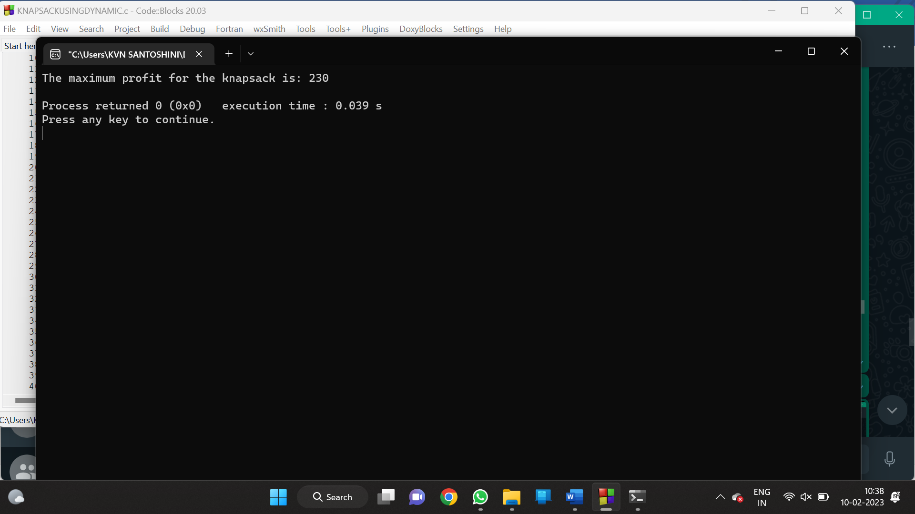

9)OPTIMAL BINARY SEARCH TREE

PROGRAM:

// A naive recursive implementation of optimal binary

// search tree problem

#include <stdio.h>

#include <limits.h>

// A utility function to get sum of array elements

// freq[i] to freq[j]

int sum(int freq[], int i, int j);

// A recursive function to calculate cost of optimal

// binary search tree

int optCost(int freq[], int i, int j)

{

// Base cases

if (j < i) // no elements in this subarray

return 0;

if (j == i) // one element in this subarray

return freq[i];

// Get sum of freq[i], freq[i+1], ... freq[j]

int fsum = sum(freq, i, j);

// Initialize minimum value

int min = INT_MAX;

// One by one consider all elements as root and

// recursively find cost of the BST, compare the

// cost with min and update min if needed

for (int r = i; r <= j; ++r)

{

int cost = optCost(freq, i, r-1) +

optCost(freq, r+1, j);

if (cost < min)

min = cost;

}

// Return minimum value

return min + fsum;

}

// The main function that calculates minimum cost of

// a Binary Search Tree. It mainly uses optCost() to

// find the optimal cost.

int optimalSearchTree(int keys[], int freq[], int n)

{

// Here array keys[] is assumed to be sorted in

// increasing order. If keys[] is not sorted, then

// add code to sort keys, and rearrange freq[]

// accordingly.

return optCost(freq, 0, n-1);

}

// A utility function to get sum of array elements

// freq[i] to freq[j]

int sum(int freq[], int i, int j)

{

int s = 0;

for (int k = i; k <=j; k++)

s += freq[k];

return s;

}

// Driver program to test above functions

int main()

{

int keys[] = {10, 12, 20};

int freq[] = {34, 8, 50};

int n = sizeof(keys)/sizeof(keys[0]);

printf("Cost of Optimal BST is %d ",

optimalSearchTree(keys, freq, n));

return 0;

}

OUTPUT:

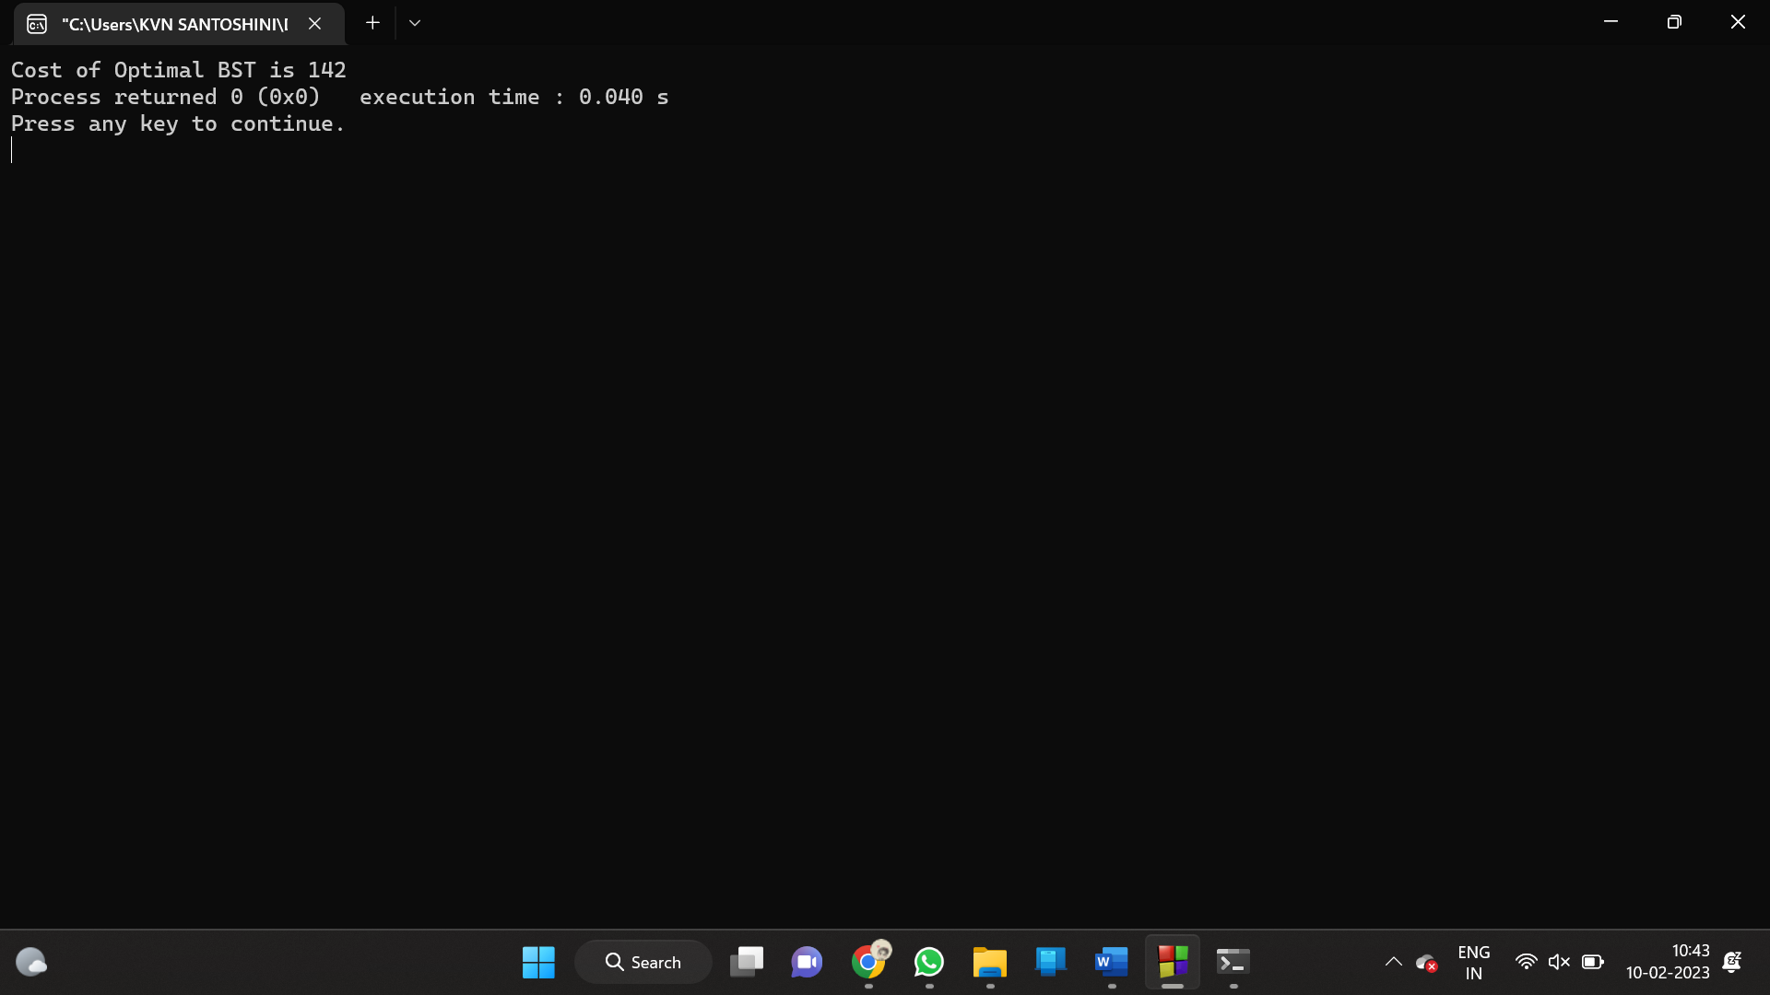

10)SUM OF SUBSETS USING BACK TRACKING

PROGRAM:

#include <stdio.h>

#include <stdlib.h>

static int total_nodes;

void printValues(int A[], int size){

for (int i = 0; i < size; i++) {

printf("%*d", 5, A[i]);

}

printf("\n");

}

void subset_sum(int s[], int t[], int s_size, int t_size, int sum, int ite, int const target_sum){

total_nodes++;

if (target_sum == sum) {

printValues(t, t_size);

subset_sum(s, t, s_size, t_size - 1, sum - s[ite], ite + 1, target_sum);

return;

}

else {

for (int i = ite; i < s_size; i++) {

t[t_size] = s[i];

subset_sum(s, t, s_size, t_size + 1, sum + s[i], i + 1, target_sum);

}

}

}

void generateSubsets(int s[], int size, int target_sum){

int* tuplet_vector = (int*)malloc(size * sizeof(int));

subset_sum(s, tuplet_vector, size, 0, 0, 0, target_sum);

free(tuplet_vector);

}

int main(){

int set[] = { 5, 6, 12 , 54, 2 , 20 , 15 };

int size = sizeof(set) / sizeof(set[0]);

printf("The set is ");

printValues(set , size);

generateSubsets(set, size, 25);

printf("Total Nodes generated %d\n", total_nodes);

return 0;

}

OUTPUT:

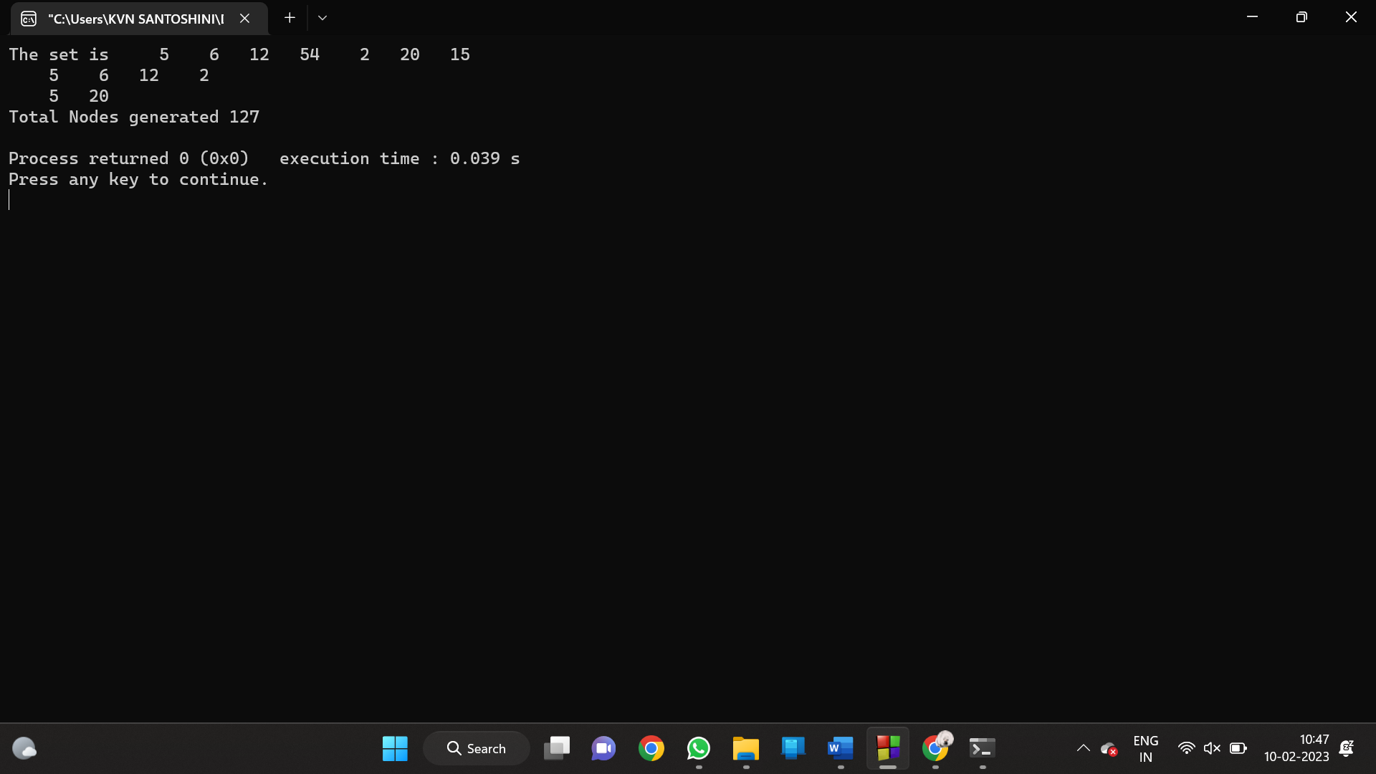

11)MINIMUM SPANNING TREE USING GREEDY TECHNIQUES

PROGRAM:

#include <stdio.h>

#include <limits.h>

#define V 5

int minKey(int key[], int mstSet[]) {

int min = INT_MAX, min_index;

int v;

for (v = 0; v < V; v++)

if (mstSet[v] == 0 && key[v] < min)

min = key[v], min_index = v;

return min_index;

}

int printMST(int parent[], int n, int graph[V][V]) {

int i;

printf("Edge Weight\n");

for (i = 1; i < V; i++)

printf("%d - %d %d \n", parent[i], i, graph[i][parent[i]]);

}

void primMST(int graph[V][V]) {

int parent[V]; // Array to store constructed MST

int key[V], i, v, count; // Key values used to pick minimum weight edge in cut

int mstSet[V]; // To represent set of vertices not yet included in MST

// Initialize all keys as INFINITE

for (i = 0; i < V; i++)

key[i] = INT_MAX, mstSet[i] = 0;

// Always include first 1st vertex in MST.

key[0] = 0; // Make key 0 so that this vertex is picked as first vertex

parent[0] = -1; // First node is always root of MST

// The MST will have V vertices

for (count = 0; count < V - 1; count++) {

int u = minKey(key, mstSet);

mstSet[u] = 1;

for (v = 0; v < V; v++)

if (graph[u][v] && mstSet[v] == 0 && graph[u][v] < key[v])

parent[v] = u, key[v] = graph[u][v];

}

// print the constructed MST

printMST(parent, V, graph);

}

int main() {

/* Let us create the following graph

2 3

(0)--(1)--(2)

| / \ |

6| 8/ \5 |7

| / \ |

(3)-------(4)

9 */

int graph[V][V] = { { 0, 2, 0, 6, 0 }, { 2, 0, 3, 8, 5 },

{ 0, 3, 0, 0, 7 }, { 6, 8, 0, 0, 9 }, { 0, 5, 7, 9, 0 }, };

primMST(graph);

return 0;

}

OUTPUT:

